

**Directions from RCSI St. Stephen’s Green to the School of Dentistry in Sandyford.**

Congratulations on joining the first intake of students to RCSI’s new undergraduate Dentistry programme. Your teaching for the year ahead will mainly take place in RCSI’s new Dentistry Building in Sandyford.

On Day 1 of your Orientation, Wednesday 17th September, you will attend your morning Orientation Sessions in the main St. Stephen’s Green campus. From an extract of the orientation programme, you will notice that you are required to attend the School in Sandyford from 14.00 – 16.00 on that first day.

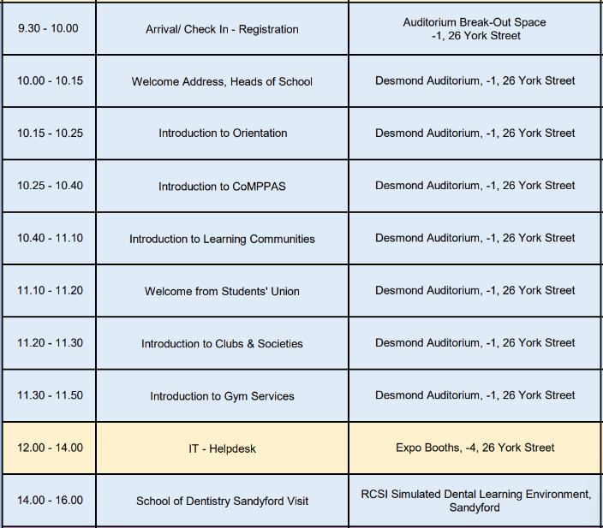

The easiest way to travel to the Dentistry School is by Luas Tram on the Green Luas line.

The St. Stephen’s green Luas Stop is located directly opposite the College. You should enter the Luas Tram on the track located closest to the St. Stephen’s Green park, i.e. the Luas, which travels South, up Harcourt Street and out of the city. The journey is 11 stops, taking 22 minutes and you will exit the Luas Tram at the Stillorgan Luas Stop. The Dentistry School is located directly opposite this Luas Stop.

**N.B.** The important thing to remember is that although the Dentistry building is located in Sandyford, you will leave the Luas Tram at the Stillorgan Stop and not the Sandyford Stop. The Sandyford Stop is the next station and will result in a nice walk back to the school - good to get some extra steps in but not great if it’s raining!

Coming off the Luas at the Stillorgan Stop, you will see the Dentistry building on the far side of the main road. Below is an image of the building. Make your way over to the building and the Dentistry team will be waiting to greet you.

